CANTEEN ORDERING SYSTEM FOR

UNILEVER

CANTEEN ORDERING SYSTEM FOR

UNILEVER

CANTEEN ORDERING SYSTEM FOR

UNILEVER

CANTEEN ORDERING SYSTEM FOR

UNILEVER

**CANTEEN ORDERING SYSTEM FOR UNILEVER**



Simplilearn Project for CBAP

Project 2

**Table of Contents**

**Introduction**

**Company Overview**

**Business analysis Core Concept Model**

**Requirement Classification Schema**

**Task:**

1. Identification of stakeholders
2. Problem Statement
3. Business Objectives
4. As-is and Future Process Map
5. Scope of the canteen ordering system using context Diaram
6. Features to be developed
7. In scope & out of Scope Requirements.
8. Activity Diagram
9. ER Diagram

10.Functional Business Requirements and non-Functional Business Requirements.

1. Use of Wireframes

**INTRODUCTION**

Established over 100 years, Unilever is one of the world’s largest consumer goods companies. It is known for their great brands, a global footprint and belief in doing the business the right way.

Company has 149,000 people across the world. Company have over 400 brand names in over 190 countries. Unilever is a global company with global purpose.

**COMPANY OVERVIEW**

Unilever is a British-Dutch MNC FMCG company, headquarter in London, England. Unilever is one of the oldest FMCG companies, and its products are available in around 190 countries. In its UK offices, Unilever had around 1500 employees. Each canteen could seat around 150 employees at a time.

**BUSINESS ANALYSIS CORE CONCEPT MODEL (BACCM)**

|  |  |
| --- | --- |
| **Need** | * To create an online canteen ordering system for the employees of Unilever, this will help them in saving the waiting time and reduce the wastage of food |
| **Change** | * Creating an application for ordering the food will help the employees to finish on time & get back to their work. This Interface will be user-friendly and reduce the wait time of the employees. |
| **Solution** | * The food application for ordering food will help the employees to finish on time and get back to their work. This interface will be user- friendly and reduce the wait time of the employees. |
| **Context** | * 1500 employees working in Unilever London. * 2 Canteens-Each Canteen could seat around 150 employees at a time. As a result, the waiting time for each employee was around 30-35 minutes.   Employees don’t always get their choice of food they want because the canteens Runs out of certain items. The canteen wastes a significant quantity of food by throwing away what is not purchased. |
| **Value** | * The Canteen management will be able to deliver food preferred by the employees and also reduce the wastage of food. * The employees will be able to eradicate the wait time which will help them in maintaining work life more efficiently. |

|  |  |
| --- | --- |
| Stakeholders | **Internal Stakeholders:**   * Project Manger * Tester * Operational/ Technical Support * Implementation SME * Domain SME   **Business Analyst ( Simplilearn)**  **External Stakeholders:**   * + Employees/End Users   + Canteen Management   + Delivery Team   + Inventory Management |

**REQUIREMENT CLASSIFICATION SCHEMA (RCS)**

1. **Business Requirements:**

Management of the ordering system online for the employees and getting the food delivered to their respective workstations so that average effective work time will be increased by 30 minutes.

The operating costs to be reduced by 15% within 12 months.

Reduce the wastage of food by a minimum of 30% within 6 months of Implementing the online food ordering system.

By making the ordering process automated and by delivering the food to the user’s workstation, the canteen will be able to operate with lesser manpower.

**2.Stakeholder Requirements:**

|  |  |
| --- | --- |
| **Customer** | Employees should be able to order the preferred food from the menu which is displayed on the online food ordering system portal with their respective prices. |
| **Canteen Manager** | The canteen manager should be able to view the orders placed by the employee. She/he should take an inventory check of all the dishes ordered by. |

|  |  |
| --- | --- |
| **Delivery Boy** | There shall be a meal deliverer (delivery boy) who shall deliver the food to employee’s desk. After delivering the lunch, the delivery boy should close the online customer order. |
| **Payroll System** | At the end of the month the payroll system shall deduct money employee’s salary |
| **Project Manager** | No. of employees using the system, looking for the most popular dishes, satisfaction of employees based on feedback, sales for each day, total monthly earnings and order forecasting. |

**3.Solution Requirements:**

**Functional Requirements**

* User Sign Up/Sign In
* Up-to date menu for the day
* Order to be placed by 11.00 am
* Create and edit the order before check out
* Delivery to the employee’s work station
* After delivery, the delivery associate shall close the online customer order.
* Customer should be able to submit the feedback regarding their orders.
* Generating of reports for management regarding the utilization of the canteen order system, reduction in operational costs.

**Non-Functional Requirements**

* Scalability and performance: Scalable for 1500 employees at a time.
* Availability: System to be light & fast
* Usability: User friendly and self-explanatory
* Maintainability: Software in Java

**4. Transition Requirements:**

* Training to the employees and canteen management on the usage of the online food ordering system ease of use.
* Data to be recorded securely and easily accessible.
* Satisfaction of the employee on using the new canteen order system.

**PROJECT TASKS:**

1. Identifying stakeholders- Create a list of stakeholders (as taught in Business Analysis Planning and Monitoring Knowledge Area)
2. Identify the problem statement in this system.
3. Identify objectives of the new Canteen Ordering System.
4. Create as-is and future process map (using flowcharts). You can use any of the popular tools in the market like Microsoft Visio, Lucid Chart, Creately, Pidoco, or Balsamiq.
5. As a Business Analyst working on the project, find out the scope of the canteen ordering system. To find the scope you can use the case diagram (UML) or context diagram for the same.
6. Write down the main features that need to be developed.
7. Right the in-scope and out-of-scope items for this software.
8. Draw an activity diagram for the system.
9. Draw an ER diagram of the system.
10. Write out the business requirements, both the functional and nonfunctional requirements.
11. Draw wireframes or mock screens for any two of the features namely menu creation and any other feature as deemed fit by the students.

(Use the technique prototyping or wire framing that is taught in the training.) You can use any of the wireframing tools like Microsoft PowerPoint, Microsoft Word, Balsamiq, Sketch, Adobe XD, Adobe Illustrator, Figma, UXPin, In Vision Studio, In Vision Freehand, or Moqups.

1. **IDENTIFYIG STAKEHOLDERS:**

**RACI MATRIX**

1. **RESPONSIBLE:** The Person who will be performing the work on the task.
2. **ACCOUNTABLE:** The person who is ultimately held accountable for successful completion of the task and is the decision maker. Only one stakeholder receives
3. **CONSULTED:** The Stakeholder or stakeholder group who will be asked to provide an opinion or information about the task. This assignment is often provided to the subject matter expert (SMEs)
4. **INFORMED:** A Stakeholder or stakeholder group that is kept up to date on the task and notified of its outcome.

|  |  |  |  |  |
| --- | --- | --- | --- | --- |
| **Stakeholders** | **Responsible** | **Accountable** | **Consulted** | **Informed** |
| Supplier | R |  |  |  |
| Tester | R |  |  |  |
| Operational Support (IT) |  |  | C |  |

|  |  |  |  |  |
| --- | --- | --- | --- | --- |
| Implementation SME |  |  | C |  |
| Project Manager |  | A |  |  |
| Canteen Manger | R |  |  |  |
| Employees |  |  |  | 1 |
| Chef | R |  |  |  |
| Inventory Manager | R |  |  |  |
| Payroll System |  |  |  | 1 |
| Deliverer | R |  |  |  |
| Business Analyst | R |  |  |  |

1. **IDENTIFYING THE PROBLEM STATEMENT IN THE CURRENT ORDERING SYSTEM**

In its UK offices, Unilever had around 1500 employees which were spread across 12 floors. They had 2 canteens to cater to these 1500 employees. Each canteen could seat around 150 employees at a time.

Most employees would prefer to take their lunch between 12 noon to 1 pm. This led to a huge rush in the canteen during lunch hours resulting in employees wasting a lot of time waiting for tables to be vacant.

Management calculated that it took around 60 minutes for employees to go and come back from lunch. Almost 30-35 minutes were waisted in waiting in a queue to collect their food and get a table to sit and eat. However, the time spent eating was barely 10-15 minutes. The remaining 10 minutes were spent reaching and coming back from the canteen using elevators.

Employees don’t always get their choice of food they want because the canteen runs out of certain items. The canteen wastes a significant quantity of food by throwing away what is not purchased.

Many employees have requested a system that would permit a canteen user to order meals online, to be delivered to their work location at a specified time and date.

The above problem/ Root cause is represented by a Fishbone diagram below:

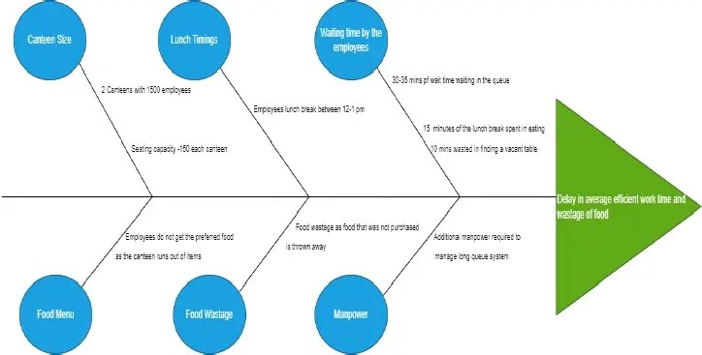



1. **OBJECTIVES OF THE NEW CANTEEN ORDERING SYSTEM**



1. Reduce canteen food wastage by a minimum of 30% within 6 months following initial release of the new system.

* Previous food wastage- 25%
* Planning to reduce wastage by 15%

1. Reduce canteen operating costs by 15% within 12 months, following initial release.
2. Increase average effective work time by 30 minutes per employee per day, within 3 months.
3. By making the ordering process automated and by delivering the food to the user’s desk, the canteen will be able to operate with lesser manpower.

**4.AS-IS AND FUTURE STATE PROCESS MAPS:**

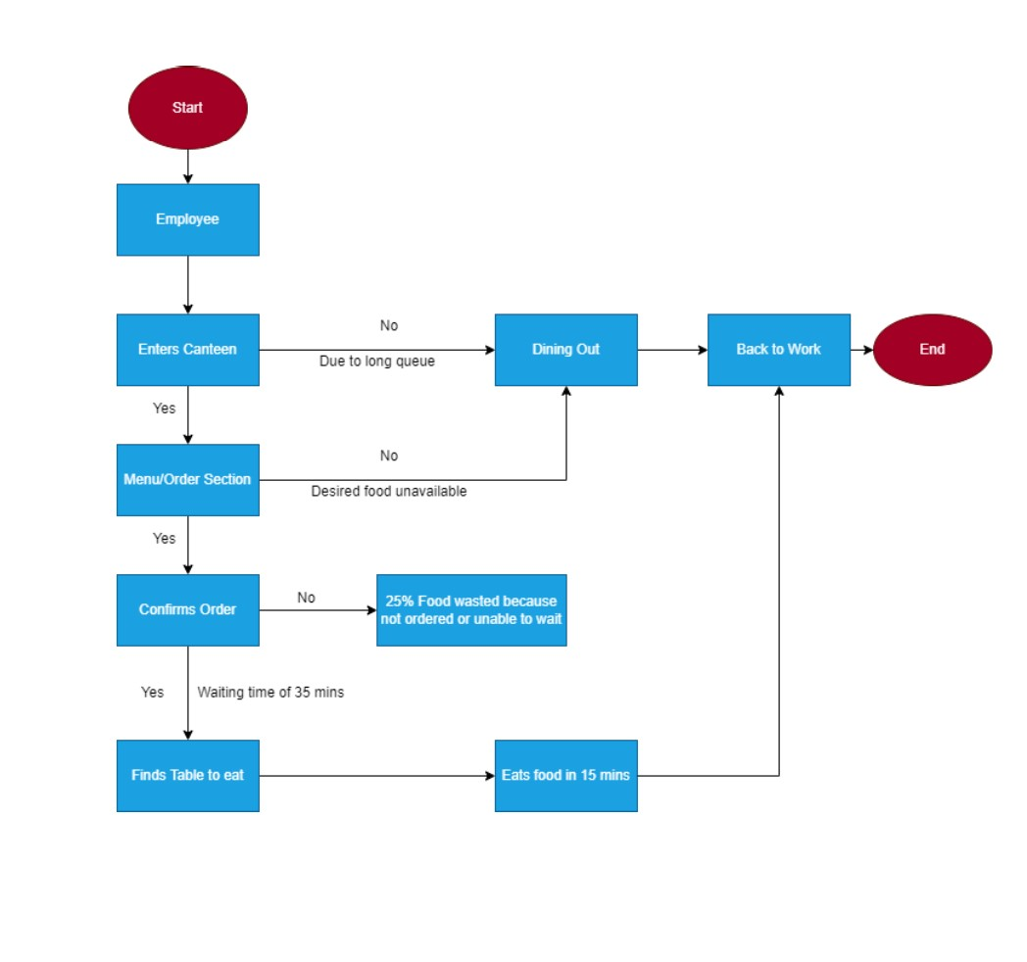

**FUTURE STATE OF THE PROCESS**

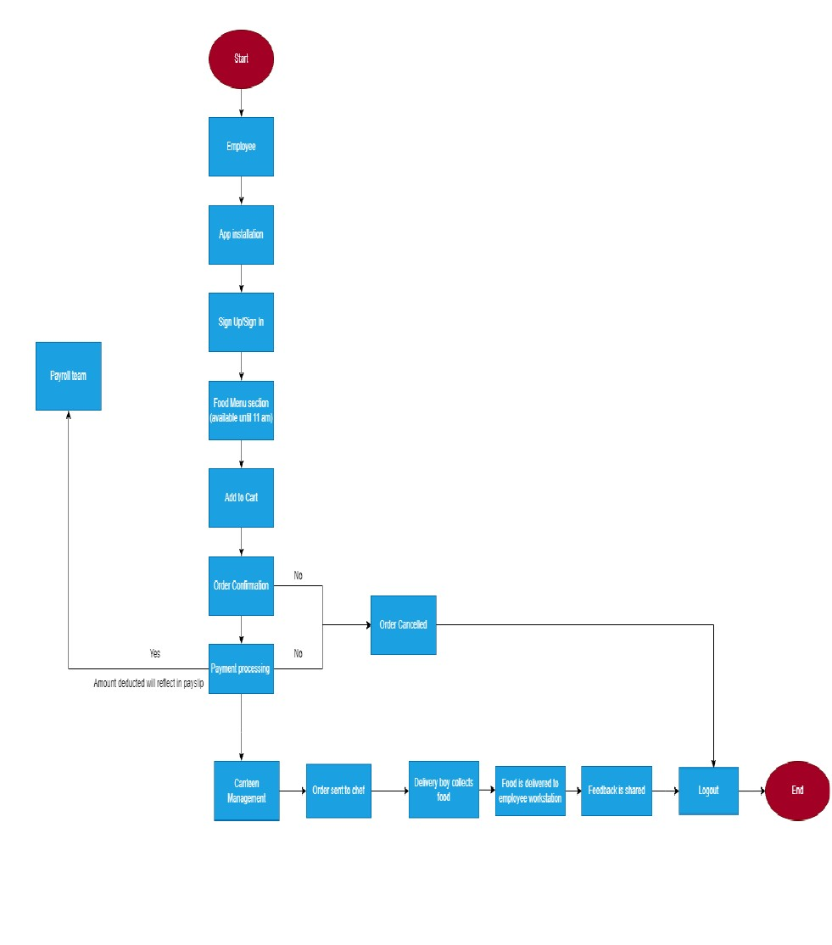

5. **CONTEXT DIAGRAM FOR THE CANTEEN ORDERING SYSTEM**

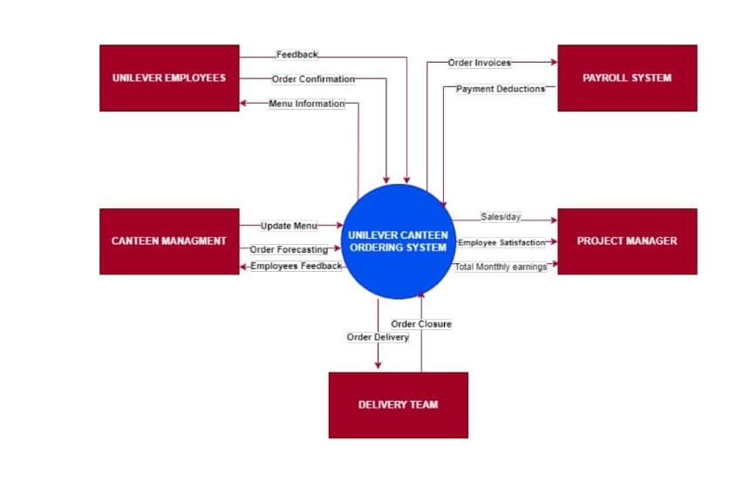

**6.Features TO BE DEVELOPED**

1. Employee registration and login credentials
2. Update the list of menu offered for the day
3. Employees must be able to select and edit the order they prefer before confirmation.
4. User will not be able to edit the order after the confirmation of the order on the system
5. The canteen manager views the orders and assign to Chef for the preparation.
6. Canteen manager also assigns a delivery associate to deliver food to the employee’s desk.
7. After delivering the lunch the delivery boy shall close the order.
8. A feedback system for the employees regarding the order.
9. The payroll system shall calculate the total number of dishes ordered by each employee. The payroll system shall deduct money from the employee’s salary.

10.Generation of the reports and submission of the same to the management.

7. **IN-SCOPE AND OUT-OF SCOPE FOR THE SOFTWARE**

**IN-SCOPE REQUIREMENTS**:

* Employee sign up/sign in
* Menu page
* Meal ordering screen
* Order confirmation screen
* Order status page
* Meal delivery details
* Close delivered order by delivery associate
* Monthly Payroll adjustment
* Feedback submission
* Sales report for canteen management system

**OUT-OF-SCOPE REQUIREMENTS:**

* Food vendor management
* Food supplies out of stock notification
* Canteen staff payment management
* Refund Options
* Chef and meal delivery person payment details

8. **ACTIVITY DIAGRAM FOR THE SYSTEM**

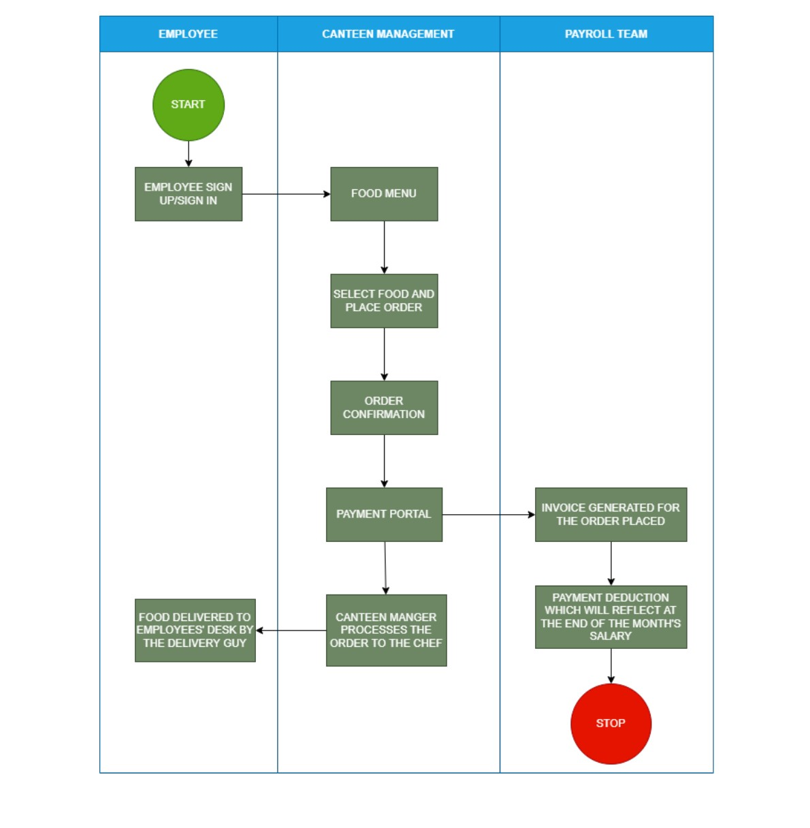

**9.ER DIAGRAM OF THE CANTEEN ORDERING SYSTEM**

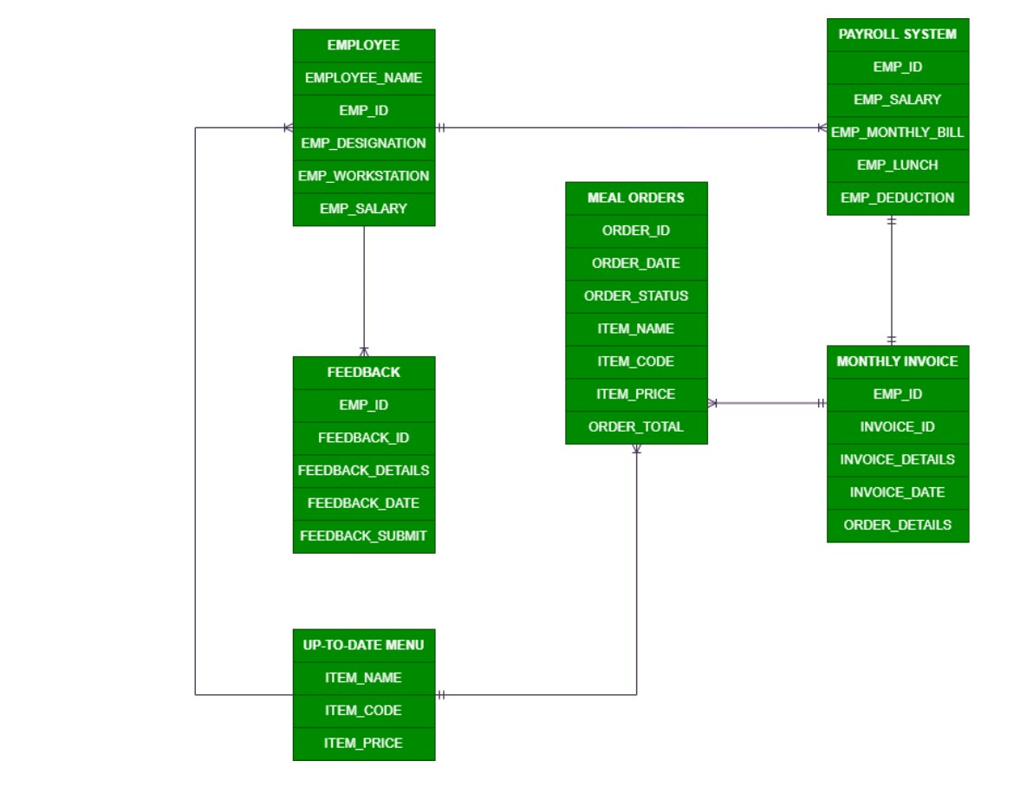

**10.FUNCTIONAL BUSINESS REQUIREMENTS AND NON-FUNCTIONAL BUSINESS REQUIREMENTS**

**Functional Business Requirements:**

* User Registration and Login
* Up-to-date Menu for the day
* Order to be placed by 11.00 am
* Create and edit the order before check out
* Delivery to employees’ work station
* After delivery, the delivery associate shall close the online customer order.
* Customer should be able to submit the feedback.
* Generation of reports for management regarding the utilization of the canteen order system, reduction in operational costs.

**Non-Functional Business Requirements:**

* Scalability & performance: Scalable for 1500 employees at a time.
* Availability: System to be light and fast
* Usability: User friendly and self-explanatory
* Maintainability: software in Java

**11.WIREFRAMES FOR THE CANTEEN ORDERING SYSTEM**

